**RoboRocket: A Framework for Collecting and Analyzing data for ADHD Assessment**

| **Hesham Salman, Jon Kissinger, Sean Mead, Troy Johnson**  Department of Computer Science, Central Michigan University, Mt Pleasant, USA |
| --- |

**Abstract -** Studies have recently shown that attention deficit disorders may affect upwards of 5% of the population. In recent years, mobile games have also become extremely popular due to the increasing ubiquity of smart phones. By exploiting this trend of mobile game popularity, we hope to create new tools to measure the symptoms of ADHD in the form of a mobile game. In this paper, we explore the results of creating a mobile game application that is capable of testing response time, distractibility, and mobile application preference in users with and without ADHD. We initially gather basic information about the user through a survey the user fills out once prior to playing the game. We predict that users with an ADHD diagnosis will have a higher variability in reaction times, higher distractibility, and will prefer mobile applications that do not focus on their reaction times as a measure of success. Previous studies have indicated that the inhibitory abilities of children with ADHD have the potential to be normalized when playing video games. This challenge means we will need sufficient data to offset any normalization. We also predict that children diagnosed with ADHD will have more mobile applications installed on their mobile devices as their short attention spans may cause them to jump from mobile application to mobile application as they may get bored rather quickly, compared to a person without ADHD. This application is a work in progress, pending IRB approval, and intended to be a proof of concept.

**Keywords:** Mobile, ADHD

# Introduction

With the recent explosion in the ubiquity of mobile devices and the mobile games that often accompany these mobile devices, a great opportunity is presented to researchers. This far-reaching opportunity allows for a large scale, geographically widespread demographic via the usage of mobile applications, removing the limitations previously imposed by a researcher’s geographic location. Studies have shown that attention deficit disorders affects upwards of 5% of the population, specifically based on epidemiological studies 2.3-4.5% of adults should have a diagnosis of ADHD. However, less than one third, approximately 1%, of the adult population has a diagnosis of adult ADHD.[8]  Furthermore, the impact on society of this discrepancy between expected and actual levels of diagnosis is high, as ADHD has been shown to be severely disruptive to adult productivity.[8]

We propose the development of a mobile application that can help collect data about users to help quantify the response time characteristics that may often accompany a person with ADHD. The mobile application would first survey the user about things such as their age, gender, ADHD diagnosis, ADHD medication usage, and other basic questions. Once the user is done filling out the survey, the user is allowed the play the game. The game will record the response time characteristics of the user as they are playing and upload the response time data to a remote server once the user finishes playing the game. From there, data mining will be performed on the user's response time data to see if there exists any strong patterns or if any relationships can be established between the response time characteristics of someone who has some form of ADHD and someone who does not have any form of ADHD. We developed a game in an attempt to keep the application entertaining and engaging to help keep the user interested and motivated to keep playing. In this way, we can collect as much data on a user’s response time characteristics as possible so that the patterns we establish have a strong statistical backing.

Our mobile game implementation will be a two-dimensional side scrolling game in which the user controls a character that moves from left to right across the screen. As the user moves from left to right across the screen, they must quickly react to jump over obstacles that appear on the screen, this is where the recording of response times for the user comes into play. The time it takes for the user to tap the screen to make their character jump over the object, compared to the time the object first appears on screen, is the time that we use as a measure for reaction time of the user. Once the user concludes playing, their response time data is uploaded to the server for further analysis.

# Related Work

There have been many studies done recently that revolve around studying the connections between reaction time and ADHD such as in [1] and [2]. However, we have been unable to find any mobile applications that have been developed for the sole purpose of collecting data to help with ADHD diagnosis and help quantify the characteristics of somebody who may possibly have ADHD, but who has yet to be diagnosed. In [3], the authors developed an adaptive intelligent game that helps diagnose ADHD with relatively good accuracy. However, the game implementation was not a mobile application. We believe that this potentially limits the audience the researcher is able to reach by a lot. If they were to make their game mobile, then they would be able to reach a much larger audience and much more diverse pool of participants. Many studies have indicated that there is in fact a link between the reaction time of people with and without ADHD. Below, we will discuss the results of some of the studies that have been performed on reaction time and ADHD diagnosis and their implications.

The authors in [4] created a computer game called Supermarket Game that essentially made the game a test for the diagnosis of ADHD. Data mining techniques were then used for determining whether a user had ADHD. Overall, the authors found their game was effective at identifying children who were classified as ADHD positive, but relatively weak at identifying ADHD disorder subtypes. It is also worth noting that this game also was not a game developed for mobile devices.

In [5] the authors conducted a study on 151 children participants. Out of the 151 children, 104 had previously been diagnosed with ADHD; the other 47 were diagnosed as not having any form of ADHD. The children performed a variety of tasks, but the task that displayed the biggest difference between the two sets of children was the Go/No Go task. The Go/No-Go test is a visual reaction test. The p value was less than 0.01 with the null hypotheses being that there was no difference between the two groups of children. This test therefore showed strong evidence that there existed a difference between reaction times for the ADHD diagnosed children and non-ADHD diagnosed children.

In [6] the authors showed that there appears to exist a relationship between the variability in reaction times in children diagnosed with ADHD and children without ADHD. The study consisted of 144 participants, 60 of which were not diagnosed with ADHD, and 84 of which had previously been diagnosed with ADHD. The participants all participated in four reaction time tasks. In these tasks, the participants all had incentive to do well because they earned prizes if they per well. Overall, the study concluded that ADHD was associated with slower reaction time and a higher variability in reaction times, similarly to the results in [5]

CogCubed is a game that was developed for the purpose of attempting to diagnose participants with ADHD [7] or possibly other disorders. However, CogCubed has a major downfall and that is that CogCubed requires a patient to have to go into a doctor's office to use CogCubed. Therefore, the user does not have access to the tool outside of a doctor's office. This is where our research contribution could be strong. Having a mobile application that is fun could lead to the contribution of a lot of data that could be analyzed and mined, which could potentially lead to stronger conclusions or maybe even new conclusions on the relationship between reaction times and ADHD diagnoses and other data that we desired to collect about the users.

# Methods

## Existing Systems

Current systems for collecting and analyzing data for the purposes of find patterns related to ADHD are limited in regards to size of the audiences that they are able to reach. A clinical diagnosis of ADHD seems to be the only purpose of currently implemented systems. They are also limited by the fact that a user must travel to the doctor’s office or a research facility to perform some kind of test that may or may not collect data about them and give them some kind of feedback on whether or not they have some form of ADHD.

For example, in [4] and [7], the authors both successfully created a tool in the form of a game that allowed researchers to gather data on the participants and analyze it to determine whether the user has some form of ADHD. However, these tools were not available in a mobile form. Putting these tools into mobile form could allow the researchers to gather much more data from a much larger and varied demographic of people. In addition, people will have easier access to the tool with it as a mobile app as they can just download the tool onto their mobile device from an internet connection. Then, they could just play the game from the comfort of their own home instead of having to go to a doctor’s office, research facility, or some other place that requires some form of travel.

## Planning of Game and Development Environment

For the design of our application, we needed to come up with a game that was simple, but fun and engaging for the user, and more importantly, was also capable of collecting data on reaction times for the user. We decided upon developing a two-dimensional side scrolling mobile platform game that requires the user to jump over objects that spontaneously pop up in front of the user on screen. The user controls a sprite on the screen that represents their location in the game, commonly called an avatar. The user’s avatar is moving from left to right across the screen at a constant speed, but the user can tap the screen to make the sprite character jump over any objects that appear.

For the development of our mobile game, we decided to use the Unity game engine because of the wide variety of both mobile platforms and desktop platforms that we are able to target with Unity. With Unity, we will be able to target mobile platforms (both iOS and Android), desktop platforms, and even the web environment, which will allow us to reach an even greater audience if our initial prototype proves to be successful. Unity allows us to easily create visually appealing environments and graphics quickly and efficiently. Unity also allows us to incorporate physics into our mobile game much easier with the use of libraries designed by Unity, so we believe that Unity will be an excellent choice and perfect fit for developing our game. A use case diagram for the mobile game can be seen in figure 1.

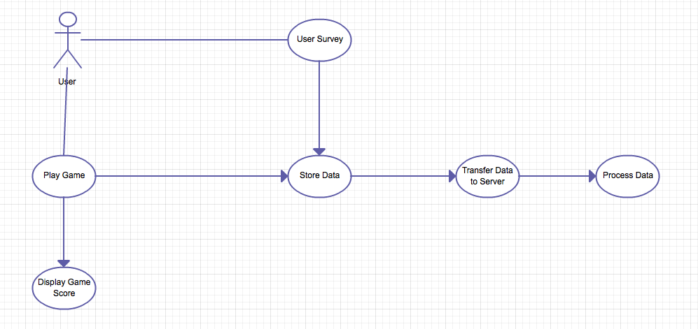

Figure 1: Use Case Diagram for Program

## Survey Development

In order to perform a statistical analysis of the games results we needed a basic survey to gather information from the user to help give us more information about the user to help find correlations or patterns that may exist in the data. We designed a survey for gathering basic information about the user from the user. Privacy is of high importance in such an application, as such we refrain from asking for any information that could personally identify the user. Further privacy measures are explored in more detail in section 3.7. In the survey, we simply ask some basic questions listed below:

* What is your age?
* What is your gender?
* Have you ever been diagnosed with ADHD?
* If so, are you medicated for it?
* If not, do you think you may have ADHD?

Note that these questions may change in later iterations of the project.

A screenshot of how the survey is displayed to the user can be seen in figure 2. We made the survey simple and brief so the user would not be put off by having to fill out a long survey before having the opportunity to play the game.



Figure 2: Sample Survey Question Screenshot

## Collecting Installed Application Information

We would also like to collection information on the other mobile applications that the user also has installed on their mobile device. Android provides native support for collecting this information, so we had to use native Android code in combination with Unity. By collecting this information, we hope to upload the application information to the server. After which we will perform analyses to test if there exists any potential relationship between the number of mobile applications the user has installed on their mobile device and their ADHD diagnosis. We would also like to assess the relationship between the type of mobile applications that the user has installed on their phone and their ADHD diagnosis. We anticipate collecting enough information to run against data mining software to detect potentially unexpected correlations.

## Collection of Game Assets

To gather images and other assets that were necessary for the creation of our game, we used images from open source locations. Open source locations let us use their images for free if they are for an educational purpose. Unity has a large set of open source assets that are available for our use, this greatly aids in our ability for easily creating sceneries, sprites, and backgrounds since we do not have to worry about spending the time designing and creating all the images necessary for the mobile application.

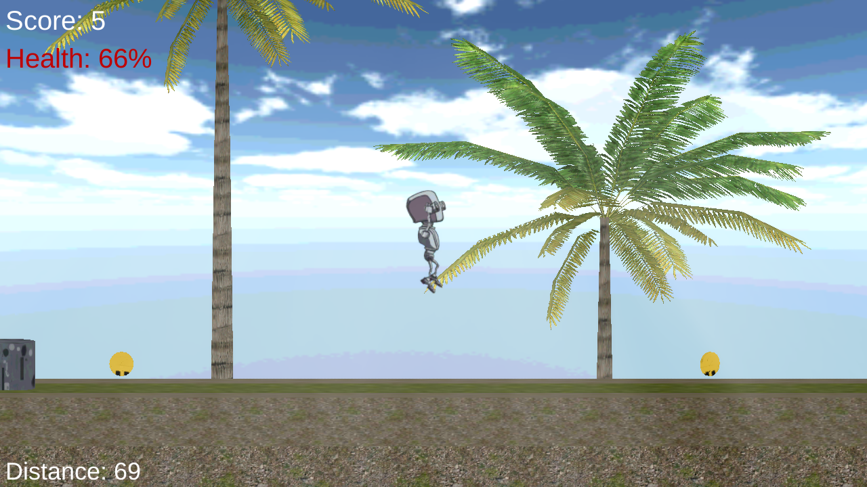

Figure 3: Screenshot of User Jumping Over Objects

## Database Design

We will have one database and that database will be housed on the server. The database will consist of four tables; a reaction times table, a survey table, a user table, and an applications installed table. It is important to note that we do not store any identifying data about the user such as their name or anything else that could possibly trace the data back to the user who submitted the data. The database schema can be seen in figure 4. We assign each user a unique user id for the purpose of organizing the data and associating each user with their own submitted reaction time data, survey data, and mobile applications installed data. In the event that a user submits more data after they have already submitted some data, we can just add the new data to their data that already exists on the server instead of creating a new entry in the user table. The reaction_time table will house the data on the reaction times the user had while they played the game. The survey table will contain the user's answers to the survey that they filled out before they were able to play the game. Finally, the user table will store data on the user such as their unique user id.

## Privacy and Security of User's Data

Due to the sensitive nature of the data that we are attempting to collect, our mobile application must be secure and must not store any data locally on the mobile device. We do not collect any personally identifiable data about users that could be used to trace the data back to the user who submitted the data.

When a user initially runs the program, a call is made to the server, which returns a unique identifier for that user. The only data submitted with this call is the type of device and OS in the case that some devices and/or operating systems may produce different or unusable results and need to be excluded. The application will store the unique identifier and in subsequent transmissions, such as submitting the survey or a set of reaction times, these can be stored securely while still being linked to the user. Therefore, the only information stored locally is the user’s unique id.

However, if there is a circumstance where there are multiple users on the same device, we will need to store additional local data on the mobile device. In this case, an anonymous identifier is generated locally to differentiate between the different users using the same mobile device to play the game and the anonymous identifier will be stored solely on the user’s mobile device. For the benefit of the user, they will be allowed to enter a name or id to differentiate between users on a single device. This name will be linked to the unique identifier in the database by the user’s device and will never be transmitted to the server.

For added security, no information, excepting the initial unique id generation, will ever be accessible from the web interface of the server. The server will respond with an error code, or a ‘Success’ message on further data submission.

## Server Set Up

A server had to be set up to accept data sent from the user's mobile device, which is uploading the data from the user for further processing along with the application data. Our server needs were not overly strenuous and we preferred open source software. Because of these factors, we chose to utilize a LAMP (Linux, Apache, MySQL, and PHP) setup for the server. We found the installation to be easy and efficient and the server runs smoothly. The server is capable of handling requests from multiple clients at once without experiencing any noticeable slow down and is secure enough to prevent any possible theft or corruption of the data that is stored on the server.

## Development of Game and Game Mechanics

To gather data from users, we thought that the best way to get a large and varied pool of sufficient data would be to develop a mobile application that is a game. This is also a technique that is under heavy exploration currently. It is sometimes termed “gamification.” Currently a research laboratory, GlassLab Games, is exploring this with grants from the Bill and Melinda Gates foundation as well as others. They have published a white paper detailing their attempts at performing psychometric testing within games.[9] Not only is this an emerging frontier, but we felt it would be entertaining for the user to play and the user may be willing to submit more data by playing longer or more often. Since the game is mobile, we would be able to reach an audience all across the United States and possibly even globally.

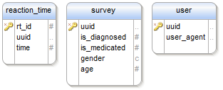

Figure 4: Database Schema

To develop the game, we first needed to decide on the game type, we eventually decided upon a two-dimensional side scrolling game. To gather response time data, we decided to have objects that spontaneously pop up in front of the user. The response time is then calculated by the amount of time it takes the user to press or tap the screen to jump over the object from the time that the object first appeared. If the user is unable to dodge or jump over these items, then they will lose a health point. When the use runs out of health points, the game will be over. The user will have a score and they can increase their score by lasting a longer period of time in the game and possibly by collecting bonus items throughout game play. Sample screenshots of gameplay can be seen in figure 3 and figure 5.

We plan on adding a leveling system so that we can make the levels become incrementally harder or just to give the user's a changeup of scenery in the game so that it doesn't become as boring as fast. The implementation of the health system, score system, and level system are not necessary, but we believe that by implementing them, we may be able to attract more users and also keep our use base more entertained and playing the game for long periods of time, which will allow us to gather a larger pool of data for each user.

In order to implement these we needed to have a variety of mechanics in the game set up for all of these tasks. A big mechanic is collision detection. Thankfully, Unity provides many tools for collision detection, which made it a much easier task for us to implement the collision detection. Collision detection is used to detect whether or not the user successfully jumps over objects or collides with any other objects on screen. Using Unity's built in physics tools, we were also able to easily allow the user’s character to jump and hence are able to make the user jump over objects by having the user click or tap on the screen.

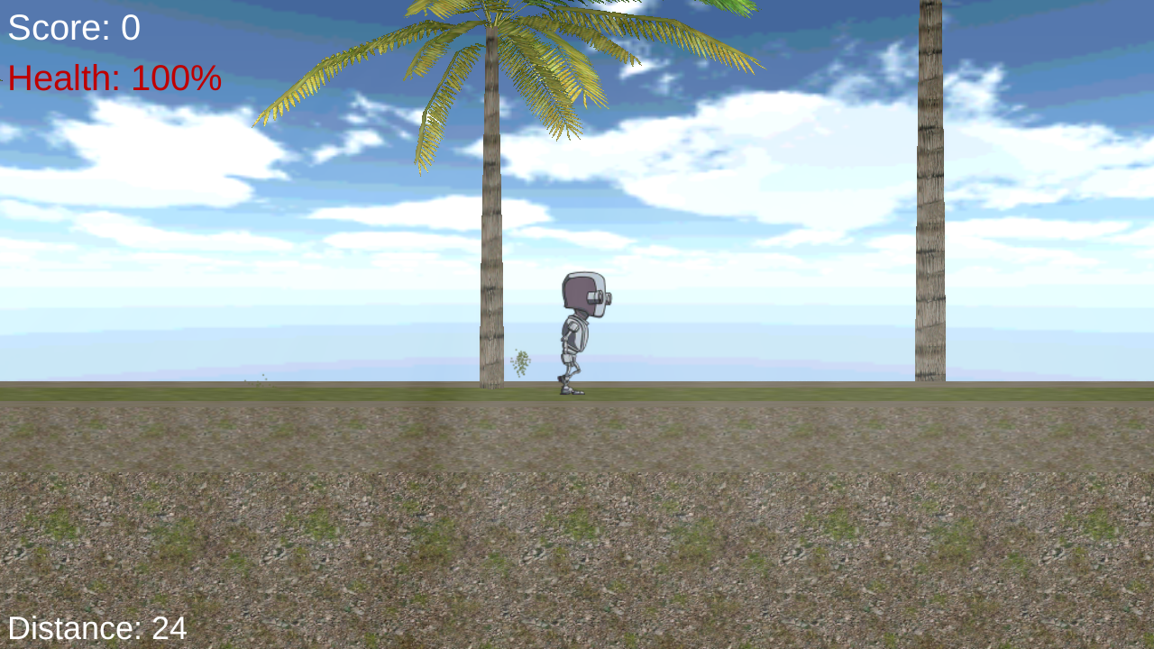

Figure 5: Sample screenshot of Character Moving Across Screen

## Server Side Scripts for Analyzing Data

Server side scripts are the scripts that reside on the server which are responsible for processing and analyzing the response time data that the users send to the server from the application in their mobile devices. These scripts are written in the Python programming language and PHP. With Python, we utilize the Numpy and SciPy libraries for performing the statistical analysis and mining of the data that is collected by the mobile application.

These Python and PHP scripts are responsible for accepting the data, parsing the data, organizing the data, and storing the data into the SQL database located on the server. These scripts are also responsible for pulling data from the server and mining the data for any possible patterns that may exist in the data. We hope to find some sort of relationship between reaction times and people who have been diagnosed with ADHD as compared to those that have not been diagnosed with ADHD. We also hope to find some sort of relationship between the number of mobile applications that the user has installed and the types of mobile applications that the user has installed and whether or not the user has been previously diagnosed with ADHD. The Python scripts look at a large variety of characteristics in the data such as correlations between variability of reaction times and ADHD diagnosis. With enough data, we hope to be able to establish strong enough confidence intervals to back our findings and show how strong our conclusions are. Unfortunately, Institutional Review Board approval is required before we can actually start collecting data from people, so we cannot yet draw any conclusions with the results from the scripts until we get approval and start collecting data from users

## User Interface

We attempted to create a game that has an intuitive interface and is simple and easy to play. The ease of use on touch devices should be good and we made the icons on the screen large enough that a user with rather large fingers should not have any troubles navigating the application and playing the game. We created a user interface in the game that should be visually appealing, but not too overwhelming that it distracts the user.

## Overall Systems

Overall, our game is fast and responsive as we intended it to be. A game that is slow and unresponsive relates to a very poor user experience and makes it unlikely that the user will want to come back to the game. Having a fun game that the user wants to come back to is one of the primary objectives of our game so that we are able to gather as much data from a user as possible. The user should not have to wait more than a second to upload their data, as our server is fast and responsive. Tests have been performed to ensure the speed of the mobile application is fast, even when the server is experiencing a heavy load, and that the mobile application is fast and efficient at uploading the data to the server.

## Results

Current work on RoboRocket is getting Institutional Review Board approval to allow us to use the mobile application for gathering data and analyzing data from people. We need to get said approval before we can release the application to the public to start gathering and analyzing data.

Once we begin to gather a larger pool of data, we will be able to use data mining techniques to find patterns in the data received from the mobile application. We are currently utilizing basic statistical methods such as correlations to find basic patterns in the data. However, the larger pool of data would provide us with much more insight into any patterns and allow us to develop and use much more advanced data mining methods for analyzing the user data received from the mobile application to help find any strong indicators of ADHD. Currently though, with the exception of the approval, all of the pieces of the mobile application are in working form and the application is capable of uploading data to the remote server where the server side scripts analyze the data for patterns. Unfortunately, we will not be able to establish any patterns in the data until we get approval and gather a large enough pool of collected data.

# Analysis of Results

Below is a screenshot of the result when a user finishes playing one round of a game. The user receives a score based on their reaction times and the duration for which they played the game. There are also other little bonuses in the game, which affect the score, but not the data recorded for statistical analysis. We also hope that by showing them and keeping track of their personal best score, they will be motivated to keep on playing and beat their personal best. This will give us great opportunity for collecting much more data on users if they are willing to keep replaying the game.

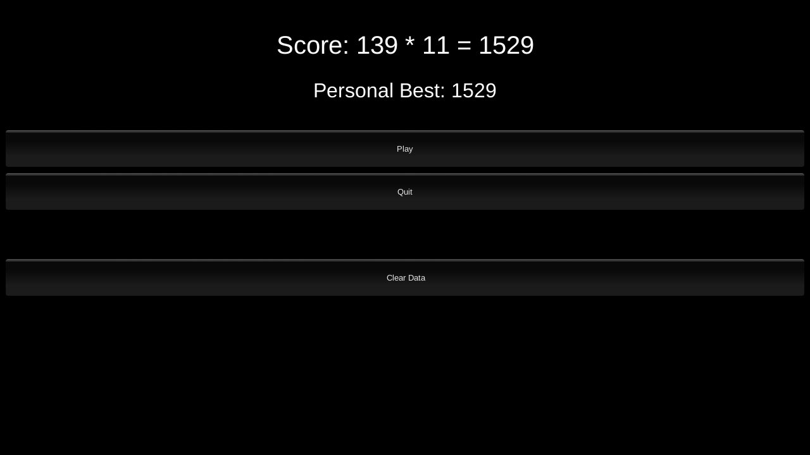

Figure 5: Users are presented with an end game score when they complete the game that shows them their score along with their personal best score.

# Conclusions

In conclusion, we have presented a basic framework for a mobile application in the form of a game that has the ability to capture and analyze data from a user’s game session to help aid in the detection of ADHD. Additionally we will add further support for quantifying the characteristics that may accompany someone who has some form of ADHD. Through a game medium, we are hopeful that people will be entertained by the application and be willing to play and play frequently. This will allow us to gather a large pool of data. In addition, by making the game a mobile game, we will be able to reach a much larger and more diverse audience that we would not have been as viable to with previous applications geared towards the same purpose. Another benefit of making the game a mobile application is that a user can easily access the game through a simple download if they have access to the internet on their mobile device.

With Institutional Review Board approval, the game should be ready for deployment to start gathering data and analyzing the data sent in from user. As more and more data comes in, we will adjust our server side scripts accordingly to look for new patterns and we are hopeful that we will be able to find strong patterns within the data.

# References

[1] S. L. Karalunas, H. M. Geurts, K. Konrad, S. Bender, and J. T. Nigg. Annual research review: Reaction time variability in ADHD and autism spectrum disorders: measurement and mechanisms of a proposed trans-diagnostic phenotype. J Child Psychol Psychiatry, 55(6):685-710, Jun 2014.

[2] Stewart H. Mostofsky and Daniel J. Simmonds. Response inhibition and response selection: Two sides of the same coin. J. Cognitive Neuroscience, 20(5):751-761, May 2008.

[3] Leila Cristina Vasconcelos de Andrade, Luis Alfredo Vidal Carvalho, Cabral Lima, AdrianoCruz, Paulo Mattos, Carlos Franco, Adriana Soares, and Bruno Grieco. Supermarket game: An adaptive intelligent computer game for attention defecit/hyperactivity disorder diagnosis. In Proceedings of the Fifth Mexican International Conference on Artificial Intelligence, MICAI '06, pages 359{368, Washington, DC, USA, 2006. IEEE Computer Society.

[4] Fabio E. G. Santos, Angela P. Z. Bastos, Leila C. V. Andrade, Kate Revoredo, and Paulo Mattos. Assessment of ADHD through a computer game: An experiment with a sample of students. In Proceedings of the 2011 Third International Conference on Games and Virtual Worlds for Serious Applications, VS-GAMES '11, pages 104{111, Washington, DC, USA, 2011. IEEE Computer Society.

[5] J. N. Epstein, J. M. Langberg, P. J. Rosen, A. Graham, M. E. Narad, T. N. Antonini, W. B. Brinkman, T. Froehlich, J. O. Simon, and M. Altaye. Evidence for higher reaction time variability for children with ADHD on a range of cognitive tasks including reward and event rate manipulations. Neuropsychology, 25(4):427-441, Jul 2011.

[6] P. Andreou, B. M. Neale, W. Chen, H. Christiansen, I. Gabriels, A. Heise, S. Meidad, U. C. Muller, H. Uebel, T. Banaschewski, I. Manor, R. Oades, H. Roeyers, A. Rothenberger, P. Sham, H. C. Steinhausen, P. Asherson, and J. Kuntsi. Reaction time performance in ADHD: improvement under fast-incentive condition and familial effects. Psychol Med, 37(12):1703-1715, Dec 2007.

[7] Sanjana Srivastava Jennifer Schumann Jaideep Srivastava Monika D. Heller, Kurt Roots and T. Sigi Hale. A machine learning-based analysis of game data for attention deficit hyperactivity disorder assessment. Games for Health Journal, 2(5):291-298, 2013.

[8] Philip Asherson, Ron Akehurst, J. J. Sandra Kooij, Michael Huss, Kathleen Beusterien, Rahul Sasané, Shadi Gholizadeh and Paul Hodgkins. Under Diagnosis of Adult ADHD: Cultural Influences and Societal Burden. Journal of Attention Disorders July 2012 vol. 16 no. 5 suppl 20S-38S

[9] GlassLab Games. Psychometric Considerations in Game-Based Assessment. Online. http://www.instituteofplay.org/work/projects/glasslab-research/